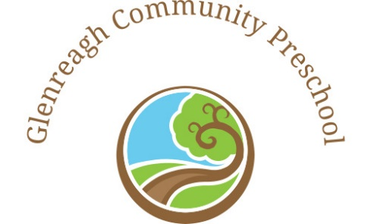

***Glenreagh Community Preschool Philosophy***

We would like to acknowledge and pay our respects to the traditional owners of this land Glenreagh that our children play on Gumbaynggirr country and who will be the future custodians of this land. We acknowledge elders present, past and emerging. We welcome all Aboriginal and Torres Strait Islander people into our learning community.

At Glenreagh Community Preschool we are a not-for-profit community-based preschool. We are currently open three days per week. We understand that our current philosophy is a living shared document and will be continually reviewed with children, staff, parents and community members. Our community is passionate to have a preschool for our children and have built and advocated for our preschool passionately through fundraising, grants and donations. Our Management Committee, team members, teachers and educators are dedicated to quality outcomes for our children. We are professionally committed to lifelong learning, continuous improvement, best practice, current research and ongoing critical reflection.

We embrace Belonging, Being and Becoming as stated in the Early Years Learning Framework. We believe that our vision is to uphold The Early Years Framework into our daily programming, The Early Childhood Code of Ethics and The Rights of the Child in all aspects of our preschool. We provide a holistic program that supports children’s social, emotional physical and cognitive development. We believe children follow their interests through play, explore, discover, create, investigate, problem solve, influence their world, think critically, take risks, explore technology and express their children’s voice of ideas and opinions. Our children learn through play and educators build on the child’s backpack of knowledge they bring to preschool. Equity, inclusion and diversity are embedded in practice. All of our children are given every opportunity to succeed and their diverse circumstances, cultural background and abilities are respected and valued.

We believe in building a local community that empowers children for their transition to school and supports their readiness for life. We strive for every child to reach their full potential.

Our children’s health, safety and wellbeing are paramount to our preschool. We are a Munch and Move service promoting a healthy lifestyle for our children. We are also a Sun Smart Cancer Council Preschool. We believe in teaching our children healthy habits for life, wellbeing and this is embedded in our practice.

We believe in teaching children environmental awareness for a sustainable Future. We aim to support our children on the benefits and importance of sustainability for future generations. Through action and critical reflection, we collaborate to make our local community and world a better place.

Collaborative, trusting and supportive relationships are developed and maintained with our parents and our local Glenreagh community. We appreciate and embrace each family and community member’s valuable input.